

Business Requirements Definition

For

Better Space Recommendations

Version: 0.7 - Draft

Authority: | Neil Hollins – Head of Space
Signature:
Authority: | Danielle Coe – SRM Programme (Infrastructure)
Signature:
Authority: | Adam Harrison – IT SRM Programme (Infrastructure)
Signature:

Author: Ian Mortenson
Date: April 2006

Document Control

Project: | Better Space Recommendations
Document Title: | Business Requirements Definition
Document Location: | \\NTH_NWOSF03\Shared\Project\Merchandising Step Change\Space Projects\1.Projects\21.Better Space Recommendations\4.BRD\Better Space Recs BRD v0.7.doc
Distribution: | Governance Group  NWT  All Stakeholders

Change Record

Date | Version | Change Description | Author
14/12/2005 | 0.1 | First Draft | Jamie Awdry
16/01/2006 | 0.2 | User specific detailed requirements amended | Jamie Awdry
19/01/2006 | 0.3 | Revisions from Business Teams | Jamie Awdry
24/01/2006 | 0.4 | Revisions from I.T. | Anne Broderick
21/02/2006 | 0.5 | Further Revisions from IT | Ian Mortenson
03/03/2006 | 0.6 | Revisions with K Whittingham’s input | Ian Mortenson
05/04/2006 | 0.7 | Merged with N Hollins’ and A Harrison’s input | Ian Mortenson

Table of Contents
1. Introduction 5
1.1 Overview 5
1.1.1 Objectives of this Document 5
1.1.2 Background 5
1.2 Project Objectives 8
1.3 Deliverables 8
1.4 Project Scope 9
1.4.1 In Scope 9
1.4.2 Out of Scope 10
1.5 Risks 11
1.6 Issues 11
1.7 Critical Success Factors 12
2. Current Business Processes 13
2.1 Overview of Generating the Space Recommendation 13
2.2 Space Modelling and Rules 13
2.3 UKBE 14
2.3.1 New Extra, Extension to Extra 14
2.3.2 New Superstore, Extension to Superstore 15
2.3.3 New Metro, Extension to Metro 15
2.3.4 New Express, Extension to Express 16
2.4 Space Changes arising from Event on the Schedule 17
2.5 Store Request for change to Space 18
2.6 Problems with Current Business Processes 19
3. To-Be Business Process 21
3.1 High Level Overview 21
3.2 Space Modelling and Rules 22
3.2.1 Commercial Category Requests - Annual Space Review 22
3.2.2 Space Modelling 23
3.3 Generating Recommendations 24
3.3.1 UKBE Changes 24
3.3.2 Space, Range and Merchandising Schedule Changes 25
3.3.3 Store Requests 26
3.4 Space Recommendations: the End-to-End Processes 27
3.4.1 UKBE New Stores/Extensions/Refits 27
3.4.2 Express 30
3.4.3 Space, Range and Merchandise Schedule 31
3.4.4 Store Requests 32
4. Requirements 33
4.1 Business Requirements 33
4.1.1 Speed 33
4.1.2 Flexibility 33
4.1.3 Better Recommendations 34
4.1.4 Rationalise 35
4.1.5 Format Cover 35
4.1.6 MGP Cover 35
4.2 Technical and Non-Functional Requirements 36
4.2.1 Non-business-facing NFRs 36
4.2.2 Business-facing NFRs 36
4.2.3 Integrity (of the Recommendations) 37
4.2.4 Usability 37
4.2.5 Environments 37
4.2.6 Security & Controls 37
4.2.7 Business Continuity Plan 37
4.2.8 Service Level Agreements and Operational Level Agreements 37
5. Assumptions 38
6. Recommendations 39
7. Project Phase Sign-Off 39
Appendix A Glossary of Abbreviations and Acronyms 40
Appendix B Glossary of Terms 41

Introduction

Overview

Objectives of this Document
This document describes the Business Requirements for the Better Space Recommendations project.

This document has 3 main purposes:
- To establish that the objectives and requirements have been correctly identified,
- To facilitate the business process sign-off with the business,
- To enable progression to the Request for Proposal (RFP).

Sign-off for this document is required to ensure that all the requirements have been correctly identified, the criteria for selecting any system tool(s) are clear and correct and that the proposed processes will fulfil the business requirements.

Background
Space is one of our most important assets – approximately 25 million square feet in the UK – and is crucial to the overall performance of the company.

Space Changes
The need for Space Changes in stores arises in a number of different circumstances. The different Space Change Types are UKBE types (New Stores, Extensions and Refits to existing Stores), Merchandising Events on the Space, Range and Merchandising Schedule and finally Store requests for change. The Space Team make recommendations of the space that each affected Store/ Merchandise Group should have and the Store then makes the changes.

Space Recommendations
Within the Space Team, space is usually reckoned in ‘numbers of mods’ of either the standard Equipment Type for the Merchandise Group (MGP) or of the Equipment Type planned for the Store/MGP. These Space Recommendations consist of the ‘number of mods’ that the MGP should have and they are made to maximise profit or revenue or meet some other Key Performance Indicator. In the case of new Stores the Space Team will be working on estimates of sales up to 3 years in the future.

Space Rules
Space Recommendations are constrained by certain rules such as “all Metros must have at least one mod of milk” or “Affluent Extras should have at least 2 mods of Fine Wine”. These constraints are known as the Space Rules (the examples are to illustrate the kinds of rule and are not necessarily actual current examples).

Adjacency Rules
These rules govern which MGPs may or must or must not be next to each other. For example there may be a rule that Tea should not be next to Soap. These rules are not currently defined.

Space Recommendations Store Clusters
Space Rules usually apply to Clusters of Stores. A Store Cluster (from a Space Recommendation point-of-view) is a group of Stores that share certain characteristics, leading to their performing in similar ways (in terms of their Sales, Profit, Level Rundown or other Key Performance Indicator, KPI, we might choose).

The following diagram represents an example of clustering:

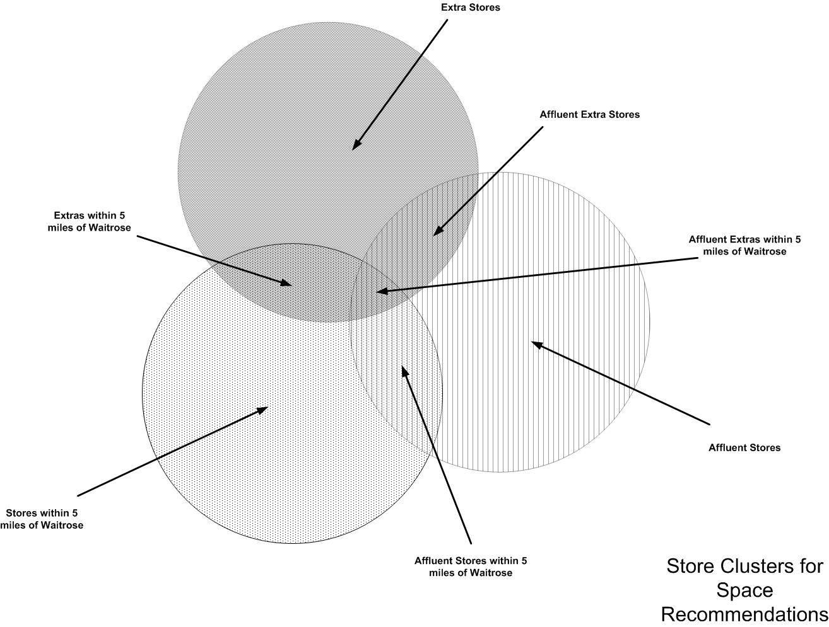

Fig 1. Store Clusters for Space Recommendations

The characteristics used to cluster Stores for Space Recommendations are not necessarily the same as those used in creating Store Ranges. For Ranging we currently use Format, Country and Affluence. For Space Recommendations, whilst we will want to use these attributes, we will also want to include other characteristics. These additional characteristics are, for example, Competition from other Supermarkets, Ethnicity, Life Style, Price Sensitivity and Population within 20 minutes of the Store.

Better Recommendations
If the changes result in more Profit (or greater Sales or better Level Rundown) then the Recommendations are adjudged to be better than those they have replaced are; they are deemed to be ‘better recommendations’.

UK Business Expansion
The UK Business Expansion programme (UKBE) plans new Stores. The Space Team recommends which Merchandising Groups should be in the new Store, which Equipment Types it should have and how much space should be allocated to each of the MGPs.

UKBE also manage Extensions and Refits to existing, trading Stores; the Space Team produces Space Recommendations for these Store/ MGPs.

Different members of the Space Team, who each use different spreadsheets and different criteria to calculate the Space Recommendations, deal with the different store formats.

Event on the Space, Range and Merchandising Schedule
When new Merchandise Plans are to be prepared for an MGP (to meet an agreed set of objectives) then an Event is placed on the Space, Range and Merchandising Schedule. The Space Team produce new Space Targets for all the Stores, which are expected to have this MGP, in order to meet the new objectives. The net change of all MGPs within a single Store must be zero. These changes to Space Targets are called Planned Space.

Store Requests
Finally Stores may request that their space for a particular MGP be increased, if they believe they can sell more of this MGP, or that the space be decreased if they believe they could sell more of something else. The net change of all MGPs must again be zero. The Space Team assesses the impact of this change and authorises the change or not.

In Conclusion
It is estimated that 20% of the store estate space is changed every year. The number of Stores in the estate is growing, the number of formats is increasing and new ways of merchandising the stores are being adopted. Under these circumstances the current tools and ways of working are proving to be too time-consuming and too inflexible. A less manual approach is required to produce space recommendations quickly. The new approach should incorporate areas currently outside of the Space Team’s remit, such as the Express format of Store and Clothing MGP. Further, it is believed that it should be possible to generate better Space Recommendations than those generated using the current processes.

Project Objectives

The project objective is:

to find a new method of producing Space Recommendations, which is future-proof, flexible and reactive to business needs, and will produce better Space Recommendations in less time by:

- Rationalising the business processes, making them easier to manage,
- Ensuring consistency across the different formats,
- Ensuring consistency across different MGPs,
- Providing system tool(s) to support the business process,
- Allowing multiple-scenario modelling.

Deliverables

The project will deliver:

- a single process which may be used to produce Space Recommendations for all Formats and all MGPs,
- a single repository to hold all the data needed to produce Space Recommendations, all the Space Rules and all current and past Space Recommendations,
- system tool(s) for producing Space Recommendations and maintaining the data to do so,
- screens and reports which show the underlying data, the Space Rules, Space Recommendations and the expected impact of implementing the recommendations, including costs and benefits.

Project Scope

In Scope

Countries Great Britain and Northern Ireland

People All Space Team.

Stores The following store formats are within the scope of this project:

- Extras
- Superstores
- Metro (all types)
- Express
- Petrol Filling Stations
- Home Plus
- Dotcom only

Stores at all stages of development – new stores, extensions, refits, refreshes and re-sites - and trading stores are all within scope.

All UK Business Expansion Stores (UKBE) and Trading Stores, including Stores with multiple floors.

Merchandise Groups All saleable products including seasonal, promotional and panel-ends.

Counters Counters such as electrical, clothing, in-store opticians, in-store pharmacy, in-store Help Desks

Other Cage Filling Bays, new Merchandising Groups and plans, Captain’s Table and POS workstation.

Out of Scope

The exclusions for the project are:

Countries Republic of Ireland (ROI), although the solution provided will need to be flexible enough able to support ROI and other countries in the future, when the standard Space, Range and Merchandising (SRM) business processes are followed. International.

Stores The following store formats are not in the scope of this project:

- World of Wine
- Vin Plus
- Pharmacy (standalone)
- Telecoms (standalone)

Merchandise Groups All non-saleable groups, for example Consumables, Raw Ingredients, fixtures (i.e. Clothing mirrors) and dummy merchandise groups.

Systems A bespoke in-house system solution, involving significant development time.

No major changes to existing systems. It is, however, accepted that some minor enhancements may be required to support data flows between any selected tool(s) and current systems.

Other Allowing for Store Hours in the calculations.
Checkouts, Off Fixture Displays, clipstrips, clear-as-you-go, pallets, foyer space and all other discretionary store space.

Risks

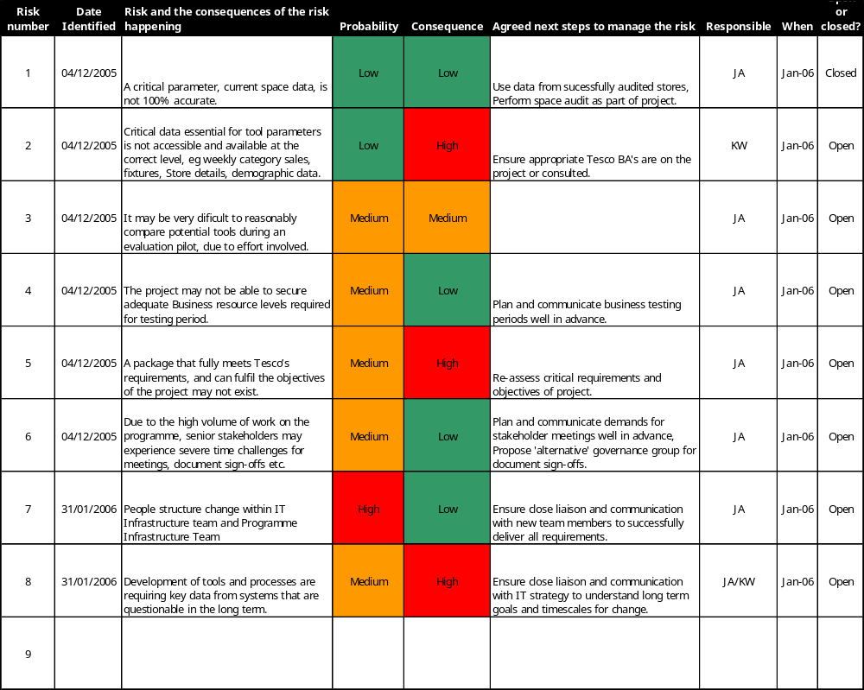

Table 1. Risks

Issues
None

Critical Success Factors

The project will have been a success if:

- all current and potential Space Rules can be loaded into the new repository, viewed and maintained,
- all the data needed to produce Space Recommendations can be imported into the new repository automatically, where the data may be viewed, maintained and exported,
- Space Rules may be generated,
- a Space Recommendation can be made significantly more quickly than now; for example a recommendation for an Affluent Extra, of 100,000 square feet, can be made in less than 1 day instead of the current 3 days,
- a Space Recommendation results in the required increase of the required KPI; for example a recommendation for a Metro to maximise Sales, when implemented results in an increase in Sales of 0.25% relative to a comparable Store, over a period of 4 weeks,
- Space Recommendations can be made for an Extra, a Superstore, a Metro, an Express and a Petrol Filling Station (PFS) using the same process, repository and tool(s),
- Space Recommendations can be made for all current trading MGPs in the business,
- Space Recommendations can be made against all currently used Attribute values new Attributes may be incorporated as and when required.

Current Business Processes

Overview of Generating the Space Recommendation

The need for new Space Recommendations arises in different circumstances: UKBE processes (such as New Stores, Extensions and Refits), or Events (on the Space, Range and Merchandising Schedule) or ad-hoc Store Requests (for a change of Space) all potentially necessitate recommendations for changes in Stores’ Space.

At a very high level the business process is the same for Space Changes of all Space Change Types, all Store Formats and all MGPs:

- the requests for new Space Recommendations come to the Space Team,
- the Space Team produce Space Recommendations/Targets,
- The Space Recommendations/Targets are then signed-off and sent to the stores,
- The stores make the change.

However, depending on the format of the Store and the Space Change Type (UKBE or Event or Store Request):

- the request comes in a different format, with different accompanying information,
- a different member of the Space Team deals with the request, using a different array of spreadsheets, different data-sets and different Space Rules,
- The sign-off process differs in structure and personnel.

The differences will be described in the sections that follow.

Space Modelling and Rules

There are a number of constraints on the Space that may be Recommended, for various Store Formats and MGPs; these constraints are called the Space Rules. An example might be “Affluent Extras should have at least 2 mods of Fine Wine”.

The Space Rules are embedded within the various spreadsheets that are used by the Space Team. This location for the Space Rules offers poor visibility of them and presents difficulties in maintaining them. Further, there is currently no formal process to maintain these rules, to bring them in line with changes to the business for example. As a result they have not been changed for over two years.

UKBE
UK Business Expansion programme plans all new Stores, Extension and Refits to all Stores of all Formats.

New Extra, Extension to Extra

The following diagram represents the generation of Space Recommendations for New Extras and Extensions to Extras; it also applies to Superstores which are being extended and re-badged as Extras:

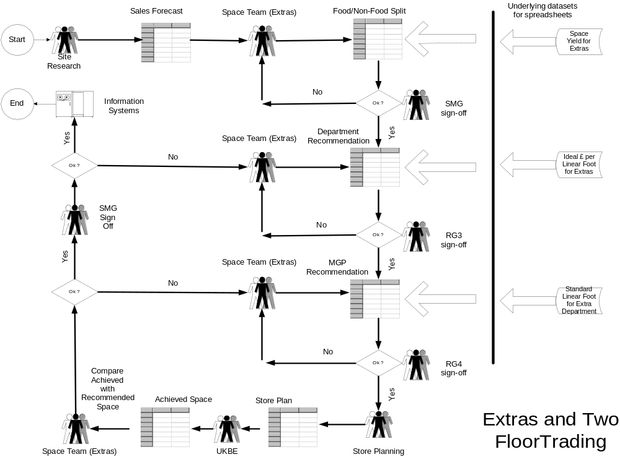

Fig 2. New Extras and Extensions to Extras

Site Research provide:

- cluster information, that is whether the Store is Affluent or Standard,
- a sales forecast for the new or extended store, broken down by 22 departments,
- expected growth, year on year, for years 2 and 3,
- food/ non-food space breakdown, in square feet: 30/20 means 30,000 sq ft of food and 20,000 sq ft of non-food.

These are entered into the spreadsheet. The spreadsheet has internal tables containing:

- space yield by MGP, showing how many linear feet of mods you get from so many square feet of space (derived from averages across the estate),
- ideal £ per linear foot for departments,
- standard linear feet per department by format, by size.

The spreadsheet shows:

- the standard linear feet, by department, for a new Extra of this size,
- the expected sales in year 3 by department,
- the number of linear feet needed to meet these sales (using ideal £ per ft),
- the totals of all sales and space.

The number of linear feet for each department is adjusted to meet the sales requirements, whilst keeping within the overall space of the new Store. A 20% margin is permitted between the standard space per department and the recommended. The total of all space, in square feet, has to equal the total in the store.

Food is worked out first. If this leaves non-food with space which generates less sales than on the Sales Forecast then this is the way it has to be.

New Superstore, Extension to Superstore
This process is very similar to that for Extras except SuperStores usually do not have Non-Food. Different members of the Space Team use different spreadsheets and different datasets to do the work.

New Metro, Extension to Metro
This process is very similar to that for SuperStores except different members of the Space Team perform it, using different spreadsheets and datasets.

New Express, Extension to Express

The process for generating Space Recommendations for UKBE Express stores is simpler than the process for all other store formats. This is due to the simplified space recommendations that are produced and the single sign off.

As Express stores are not on the Space and Merchandising System the Space Targets are sent to the Store in the form of a spreadsheet.

The following diagram may represent the process:

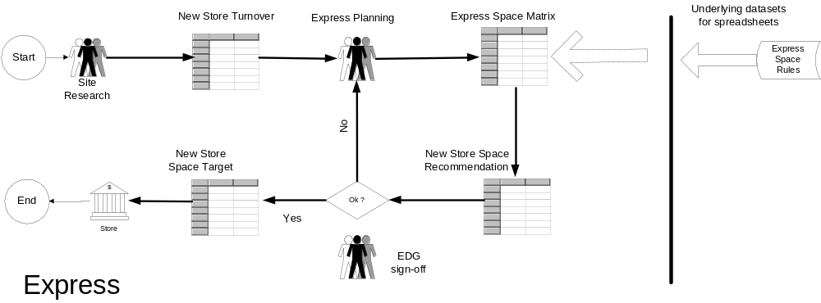

Fig 3. New Expresses and Extensions to Expresses

Site Research refers to the Express Development Calendar (not shown) and then produces a New Store Turnover calculation. This data is passed into the Express Space Matrix.

The Express Planning team use the New Store Turnover and the Express Space Rules to produce a New Store Space Recommendation.

Express Development Group (EDG) then signs off this Space Recommendation and the Space Targets then get passed to the store. If the Space Recommendations are not signed off then Express Planning rework the data to produce a subsequent New Store Space Recommendation.

Space Changes arising from Event on the Schedule

Space Changes arise from Events, which have been placed, on the SRM Schedule. For example, suppose a decision is made to change the Merchandising for a group of Merchandise Groups, say Meat. It may be that sales of pork are expected to decline and sales of poultry to increase because it is believed that people are becoming more health conscious. Conversely it may be believed that sales of poultry will decline due to fear of avian ‘flu. Or it may just be that the season is changing from Winter to Summer, sales of frying and barbecue meats will increase and sales of stewing meats will fall: space must change in the Stores to reflect this.

An Event is put on the Merchandise Schedule and details are passed to the Space Team. The process may be represented:

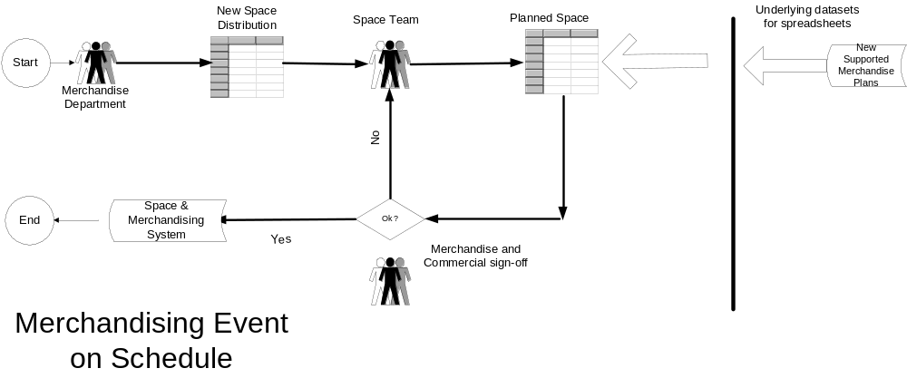

Fig 4. A Merchandising Event on the Schedule

Merchandising generally provides details of the changes they require. For Produce say, this is done in or before Week–10; in Hardlines they provide the changes much earlier. The Space Team determine the Planned Changes between Week–10 and Week–8; for Hardlines this is done around Week-20.

In the case of Produce, for example, there may be four different Clusters {Upmarket Super/Extra}, {Standard Super/Extra}, {Upmarket Metros}, {Standard Metros} and the Stores may range from 100 mods to 10 mods. Produce may cover say 30 MGPs. For each Cluster, for each number of mods, Merchandising provides the split they require over the MGPs.

The Space Team works on a spreadsheet of Store/MGPs, identifies the Cluster for each Store and plugs in the values of mods.

For a non-Food area Merchandising typically provide a selection of requirements. For example if there were 3 MGPs in an Event (say H1A, H2A and H3A) they might provide a split for Stores with 10 mods, with 20 mods etc.:

TotMods H1A H2A H3A
10 5 2 3
20 10 4 6
30 16 7 7
etc.

They also provide a priority, say H1A = 1, H2A = 3 and H3A = 2.

The process is much as with Produce if the Store has 10 mods or 20 mods. If a particular Store has a total in between 10 and 20 mods, say 11 mods then the split is used as a guide; the priorities are used to increase or decrease the space but the final value must correspond to a supported plan. The result might be H1A=6, H2A=2 and H3A=3. This results in a lot more work of course.

When all the Planned Changes have been entered into the spreadsheet then the sheet is sent to Merchandising and they, together with Commercial, agree that the changes are in accord with their requirements. If not then the comments are passed back to the Space Team for further changes. The Space Team has until the end of Week–8 to get this right.

The changes are loaded up into GR and are visible to the Stores from Week–6.

The results are very much for an average Store and no Sales data have been taken into account. So the recommendations may not be appropriate for all Stores. Also some Stores have pillars, in particular places, which make the recommendations difficult to effect; in other cases adopting the recommendations may force a MGP around a corner. In all these cases the Stores have from Week–6 to Week–4 to complain and request a change of recommendation. The Space Team usually agrees.

Store Request for change to Space

It may be some time since space was last looked at in a particular Store; it could be months or years. The sales patterns may have changed in this time and the Store may believe that they could sell much more of some MGPs and perhaps less of others. They request a change of Space for the MGPs.

The Space Team compares the last Space Recommendations with the Requested Space. The Space Team also considers the Space Rules and the Supported Merchandise Plans. Finally the change is approved, and a Planned Change is created, or it is refused.

Problems with Current Business Processes

There are a number of problems with the current business processes; some of these problems are severe. These problems:

- Make the process slow:
- The current sign off procedure is lengthy and requires many iterations;
- Lengthy time delays exist between different departments when reviewing and re-working recommendations; recommendations are signed off at Food/Non-food, Department and MGP level by different people,
- The manual import and manipulation of data within the spreadsheets is time consuming,

- Arise from the inflexibility of the current tools:
- Inability to plan more than a year ahead,
- Unable to make space recommendations based on all possible store clusters; for example, ethnicity is not currently used,
- Working across more than one floor is very manual and cumbersome; to generate the best recommendations it should be possible to flex all MGPs across all floors,
- Inability to take adjacency rules into consideration,
- Various lacks of visibility make management difficult and lead to uncertainty in the recommendations; these include:
- Limited visibility of the recommendations and subsequent reviews,
- Only the last recommendation for each store is available,
- No audit trail, of the various iterations of the recommendations, available,

- Can lead to poor recommendations:
- The manual import and manipulation of data within the spreadsheets is subject to human error,
- Inability to create completely new unconstrained models, not linked to existing supported space nor existing stores; certain better recommendations might never being discovered,
- Inability to forecast the cost of a recommendation, and hence to assess the worth of the recommendation,
- Time-consuming and cumbersome to review accuracy of recommendations following implementation of space changes; this is the only way of ensuring recommendations are indeed good,

- Concern the diversity of the different processes and tools. This leads to difficulties in managing the process and the detection of errors:
- There is no one common process nor tool that supports all store formats, locations and store status; this leads to problems when someone has to take over another persons work (during holidays or sickness),
- Different data sources are used within the various processes; for example some formats use 8 weeks sales and others use 12 weeks,
- The lack of a central and single source for Space Rules, makes it difficult to manage the Space Rules and difficult to ensure their consistency and accuracy,
- There is limited visibility of the Space Rules outside Space Team; people don’t understand how and why the recommendations were made,

- Prevent Formats being covered:
- Not all formats are currently catered for, e.g. PFS,

- Prevent MGPs being covered:
- Not all departments are currently catered for, e.g. Clothing,

To-Be Business Process

High Level Overview
The signing-off process for Extras will continue to be more complex than the sign-off process for Expresses. The activities and documents associated with UKBE-driven Space Changes will continue to be different from those associated with SRM Schedule-driven Space Changes.

All of these different processes however will use a single set of data, a single set of Space Rules and a single mechanism for generating Space Recommendations and Space Targets. The dataset, Space Rules and mechanism can be considered as a single entity, the Space Modelling and Recommendation System, and it is logically represented in the following diagram:

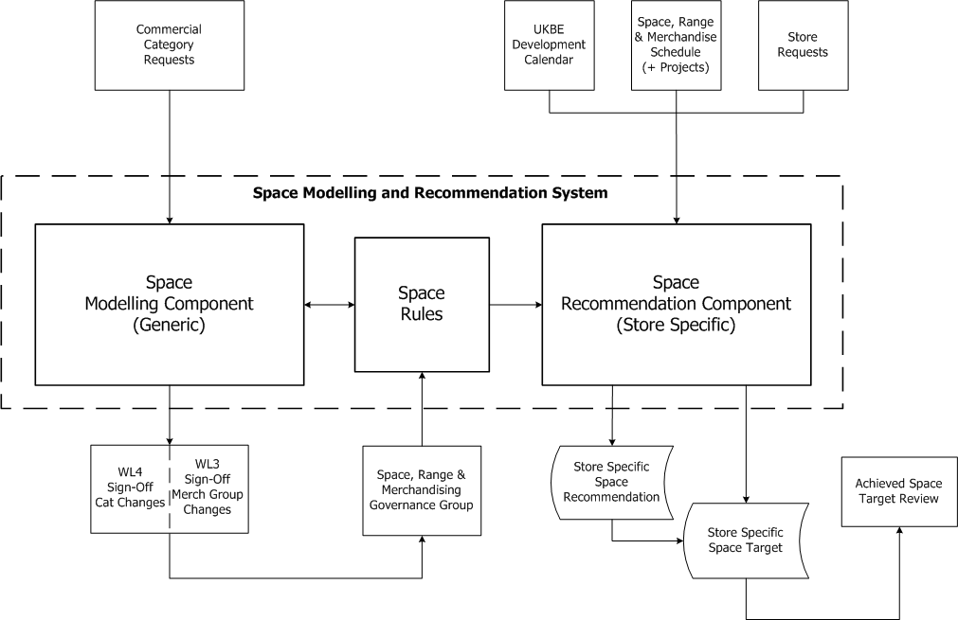

Fig 5. Space Modelling and Recommendation System

Although this is a logical representation of the system, it is expected that the Space Modelling capability (for the analysis of all current data leading to the generation of Space Rules), the Space Rules themselves and the software which is used to generate the Space Recommendations will all actually be held within the new Space Modelling and Recommendation System.

Space Modelling and Rules
The left-hand side, the generic side of the logical model, represents space Modelling and Space Rules:

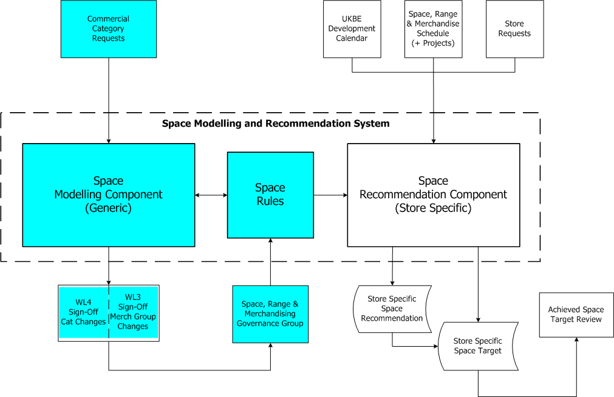
Fig 6. Space Modelling

Commercial Category Requests - Annual Space Review
Business requests to review and amend Space will be put forward at the Annual Space review. The Space Management team will analyse and propose changes to Space Rules, in line with these requests.

Space changes proposed in the review generally fall into 2 categories:

- Departmental – these changes impact one or more departments, and are reviewed and agreed by the Space, Range and Merchandising WL4 Manager,
- Single Merchandise Group - these changes impact one Merchandise Group, and are reviewed and agreed by the Space WL3 Manager.

All changes will be presented to and reviewed and agreed by the Space, Range and Merchandising Governance Group. This approves the changes for use within the wider Space Recommendations process and updates the Space Rules.

The changes will come into effect the next time a Space Recommendation is made.

Space Modelling

The Space Modelling and Recommendation System will be able to analyse sales or profit (or other KPIs) achieved in recent times, detect changes in trends and make predictions about future performances. Based upon these predictions new Space Rules may be generated. These new Space Rules will lead to future Space Recommendations which will be in line with the predicted performances.

It will be possible to generate new Space Rules using what-if scenarios. These Space Rules will be subject to the approval process.

It will be possible to generate Space Recommendations in this what-if mode, using the new Space Rules, without authorising these Space Rules as live.

What-if scenario modelling may be performed here to predict future performance. It will be possible to introduce a new Store format or a new Ranging Attribute Type or change the Attributes of a particular Store and see what the impact would be on the estate.

Generating Recommendations
Space Recommendations and Targets are Store Specific and relate to the right-hand side of the logical model. They are generated using the Store’s actual size and layout.

UKBE Changes

The trigger for the generation of Space Recommendations is the presence of the Store on the UKBE Development Calendar. The generation of the Space Recommendations (and subsequent Space Targets) for these UKBE-driven changes is represented by the right-hand side of the logical model:

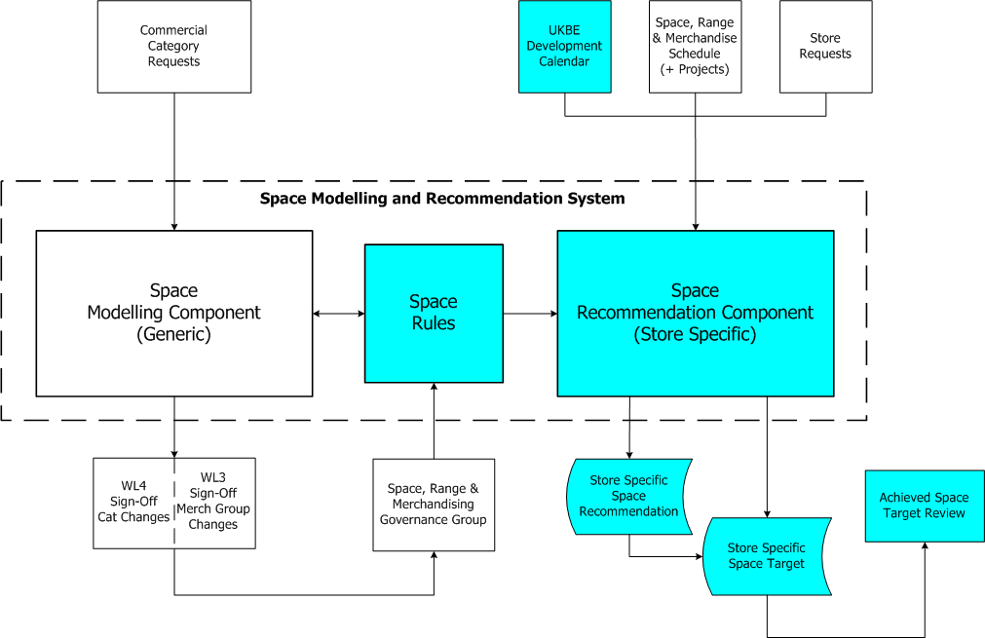

Fig 7. UKBE Space Recommendations and Space Targets

The new total Space is fed into the Space Modelling and Recommendation System.

The KPI(s) to be maximised is entered and a request for a new Space Recommendation is made. The Space Recommendation, and its impact, are generated. The impact will show the expected performance improvement and the cost of effecting the changes in Space.

If the Recommendation is acceptable then this too is entered into the Space Modelling and Recommendation System and a Space Target is generated and sent to the Store.

Space, Range and Merchandising Schedule Changes

Any changes to the Space Rules, arising from Commercial Category Requests, will have been approved and modelled in the Space Modelling and Recommendation System.

Space Targets, for these SRM Schedule-driven changes will be generated, using the new Space Modelling and Recommendation System. The Space Rules and generation of the Space Recommendation are represented by the the right-hand side of the logical model:

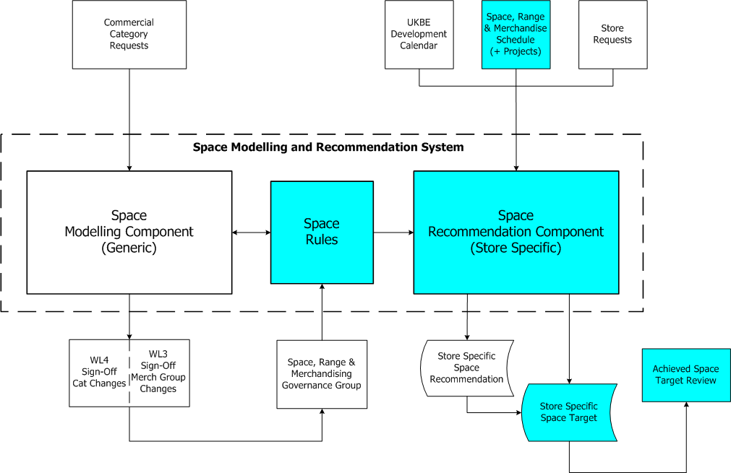

Fig 8. Space, Range and Merchandising Space Targets

The Event and MGPs will be entered into the new Space Modelling and Recommendation System. The Space Rules will already have been changed to reflect the objectives of the Event.

The Space Targets will be generated for all the Store/MGPs affected by the Event. These Space Targets will be sent to the Stores; they will be compared with the space actually achieved in the stores later on and a report will be produced.

Store Requests

A Store may believe that it could achieve better sales or profits by altering its space. The store may request a change in its Space Targets at any time. The Space Team will use the new system to validate this request. This is represented by the right-hand side of the following diagram:

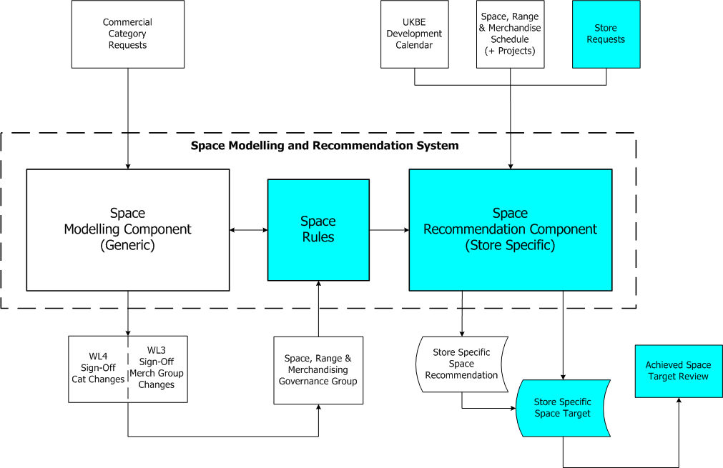

Fig 9. Store Requests for Change in Space

In this instance there will be no changes to the Space Rules nor to the current Store information (on sales, profits, total space etc.). The Space Team will use the Space Modelling and Recommendation System to generate a new Space Target.

This new Target will be sent to the Store. The new Target will later be compared with the space actually achieved in the store and a report will be produced.

Space Recommendations: the End-to-End Processes

UKBE New Stores/Extensions/Refits

The new Space Modelling and Recommendations Systemwill be at the heart of the end-to-end process for UKBE New Stores, Extensions and Refits. It will generate Space Recommendations at the level of Food/ Non-Food Split as well as at Department or MGP level.

The new Space Modelling and Recommendations Systemis shown as the process Produce Recommendations (3, 13) in the following diagram:

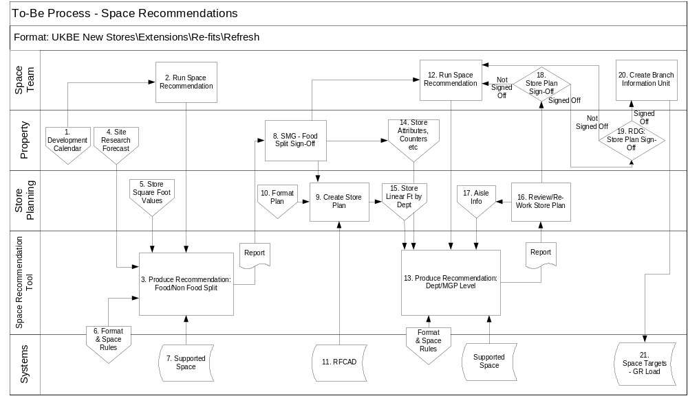

Fig 10. UKBE the To Be End to End Process

The diagram shows the full process from initiation through sign-off to publishing of Space Targets. The various stages in the process are described below.

Generating the Food/ Non-Food Split

For UKBE to initiate a Space Recommendation the Store/ MGP must be on the UKBE Development Calendar (1). Site Research (part of the Property Department) will create the Site Research Forecast (4) for the Store. This document will show expected sales, projected store specific sales and growth. The Property department will also produce Store Attributes, Counters etc. (14), a report that will include such details as Counters, Pharmacy and other services offered, that will be used in step 13.
.

The Store Planning department will produce Store Square Footage Values (5), a report showing actual values for the store, that will constrain the Space Recommendations at a high level. The Store Planning department will also produce the Format Plan (10), a report showing overlays that will be used to create new store plans in stage 9.

The presence of a Store/ MGP on the UKBE Development Calendar will initiate the next stage, which is the Space Team generating a Space Recommendation (2), at Food/ Non-Food split.

During this generation process the new Space Modelling and Recommendation System (3) is used. The new Space Modelling and Recommendation System will previously have been used to produce the Format and Space Rules (6) that will be be used here. The remainder of the Format and Space Rules will have been manually maintained.

Supported Space (7), which will have been imported from the MIS data warehouse, is also used in generating Space Recommendations.

The new Space Modelling and Recommendation System will produce a report, showing the Space Recommendation for the Food/ Non-Food split. The Space Team and the Stores Marketing Group (8) will use this report as the sign-off document. If the report is not signed-off then the Space Team must go back to (changing the Space Rules and) generating a new Space Recommendation.

Creating a Store Plan
The signed-off document will be used by the Store Planning Team to create a Store Plan (9). This process will also create the Store Linear Footage values (15), to be used later in a step (13). The Store Plan will be amended as Food/Non-Food spit, Department and MGP level recommendations are approved.

The Format Plan (10), previously created by the Store Planning department, will also be input into this process. Additionally data will be taken from RFCAD (11), a system that currently provides an electronic layout of the store and is used in designing the store layout. The current plan is to decommission RFCAD; should this happen before this project is delivered then there will be a different system to extract data from.

Generate the Department/ MGP level Recommendation
After the Store Plan has been produced the Space Team will use it to produce a more detailed Space Recommendation using the new Space Modelling and Recommendation System (12).

The new Space Modelling and Recommendation System will produce a Space Recommendation. First time through this will be done at Department level (13); when the Recommendations at Department level have been approved then a recommendation is produced at Merchandise Group level (also 13). Space Rules and Supported Space will be taken into account for this recommendation. Store Attributes (14), which will have been provided by the Property department, will also be input into this process.

Store Linear Footage by Department (15), which was an additional output of Store Plan creation (earlier in step 9), will also be an input into the Recommendation process. During the second and subsequent iterations of this Space Recommendation, Aisle Information (17), produced during the later step 16, will also be an input and should provide enough information to recommend space splits within adjacency rules. A report will be produced of the Space Recommendation.

Review of Space Recommendation
The Report, of the recommendation, will be used by the Store Planning Team to review the Space Recommendation (16). This process will also generate Store Aisle (17) information, which may be used in future iterations of this Recommendation.

If the review is unsatisfactory then the Store Plan must be re-worked and new constraints appied to the model. Process will resume at step 12.

Sign-off the of Space Recommendation
The Store Plan will be Signed-off (18), at a meeting held between Store Planning and the Space Team, to agree the Store Plan. If not approved then the Store Plan must be re-worked and new constraints appied to the model. Process will resume at step 12.

If the Store Plan is signed-off then the Retail Development Group will review and sign-off the Store Plan.

If this is not approved then the Store Plan must be re-worked new constraints appied to the model. Process will resume at step 12 to generate a new Space Recommendation.

Create Branch Information Unit
The store’s Linear Footage by Department (15) will be converted into numbers of mods. A Range Class and a Region Code will be assigned to each MGP of the Store. The Numbers of Mods, Region Code and Range Class will be shown on a report known as the Branch Information Unit (BIU).

The numbers of mods will become the new Space Targets. The Space Targets and Range Classes will be loaded into the Space and Merchandising System (currently GR) as Planned Changes for that MGPs.

Express

The To-Be Process for Express will be similar to the current process, except simpler: the new Space Modelling and Recommendation System will be used to both hold the Space Rules (instead of having a separate datastore) and to generate the Space Recommendation instead of using spreadsheets.

The following process diagram may represent the process:

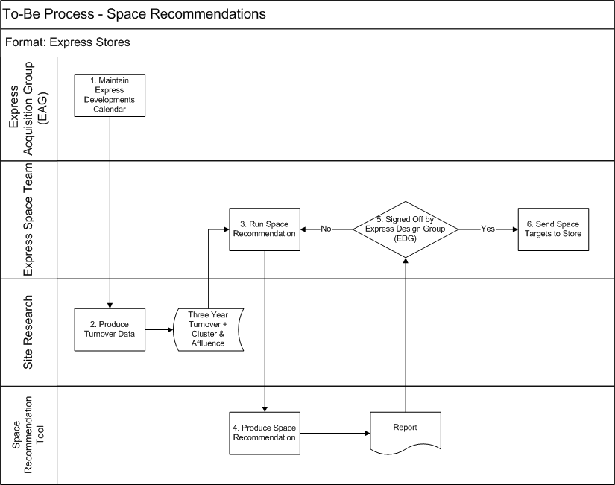

Fig 11. New Expresses and Extensions to Expresses

The use of the new Space Modelling and Recommendation System is shown as steps 3. and 4.

The process has fewer steps and involves fewer personnel than the current system.

Space, Range and Merchandise Schedule

The To-Be End-to-End Process for a Merchandising Group that is on the Space, Range and Merchandise Schedule may be represented by the following diagram (culled from the Pre-Ranging 2 Business Process Document). The Space Recommendation parts are shown as lightly shaded.

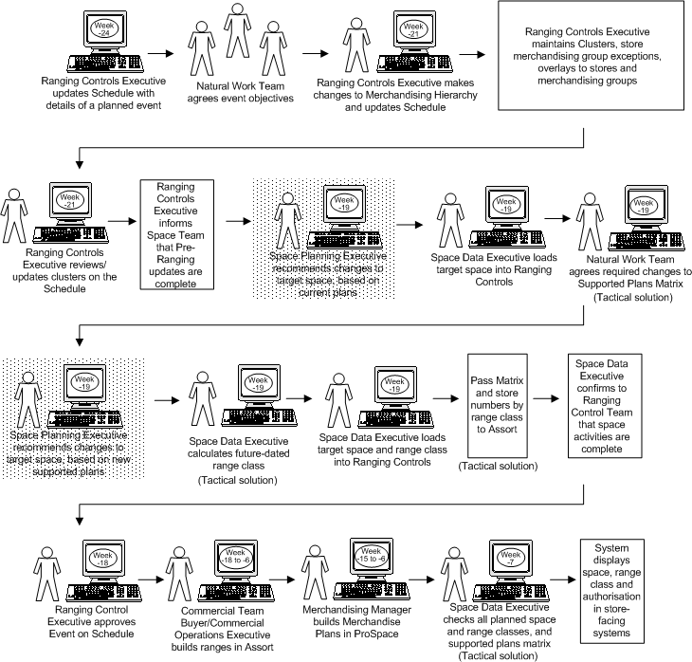

Fig 12. To-Be: Scheduled Ranging Merchandising Event

Store Requests

If the Stores requests a change of Space then the new Space Modelling and Recommendation System will be used to generate a new Recommendation. This new Recommendation will be compared to the current Space Target. If the new Space Recommendation is different it will be sent to the Store for them to effect.

Requirements

Business Requirements
The following are the Business requirements for Better Space Recommendations.

They are grouped according to which part(s) of the project objective they help to achieve; that is they help to:

- improve speed of producing Space Recommendations,
- increase flexibility in generating Space Recommendations,
- generate better Recommendation,
- rationalise the process,
- improve Format Cover,
- improve MGP Cover

Speed

- Ability to produce recommendations in a timely manner, i.e. in minutes rather than hours
- Ability to generate new Recommendations automatically

Flexibility

- Ability to enter new Recommendations manually
- Ability to trade Merchandise Group Space within current fixture constraints and adjacency rules, i.e. not to swap Fruit with Frozen Meat
- Ability to plan from fixture constraints
- Ability to set a maximum amount of space available for a store. This may be used for extension stores and when reducing the store trading floor
- When creating future-dated space recommendations the latest, previous recommendation is to be taken as the ‘current’ position
- Ability to best fit the store to its local trade environment (E.g. ethnically ranged merchandising groups in ethnic stores)
- Provide the ability to fix some merchandising groups, while others are allowed to flex within specified limits
- Ability to extend and reduce store size and re-optimise the layout accordingly. This may be used for extension stores and when reducing the store trading floor
- Ability to relocate merchandising groups to different areas, or even floors, within a store. There may be constraints on which MGPs may be on which floors. This will be used for Two-Floor Trading (TFT) and extension/ refit/ refresh stores.
- Maximise key business Key Performance Indicators (KPI), such as revenue/ profit/ Level Run Down) for each merchandising group in every store in the estate
- Generate store specific and week specific space recommendations by merchandising group, i.e. to take seasonal adjustments into account
- A comprehensive set of reports to be created to replace the current suite in use. These reports will be for the Stores Marketing Group (SMG), the Retail Development Group (RDG), the Express Development Group (EDG) and space sign off meetings
- Ability to model all space change types in scope of this project
- International capabilities, i.e. screens and reports which can easily translate into foreign languages
- Ability to generate Space Recommendations at different levels (e.g. Department level, Food/Non-Food)
- Ability to extract any data held within the system
- Ability to automate all data loads, manually import data
- Ability to adjust calculations, to manually amend parameters and weighting of parameters used for each recommendation
- Ability to integrate with other tools, systems; e.g. linking to datawarehouse and Space and Merchandising systems
- Ability to deal with all fixture types
- Ability to control data transfer import/export timings
- Require automated and Standard reporting, as well as on demand
- Ability to print all screens
- Ability to change reporting currency at server level
- Ability to produce multiple future-dated space targets for a store/ merchandise group, including equipment type
- Ability to plan for changing demographic trends
- Define the key trade drivers (affluence/ ethnicity) for each store and understand how these would impact on key KPI’s and space
- Ability to target specific customer segments and create store specific space predictions (E.g. Ethnic)

Better Recommendations

- Ability to produce Space Rules by analysing data
- Identify stores / merchandising groups with potential for revenue growth. This will be used for when a merchandising schedule change allows us to make small space changes to maximise key KPIs
- Identify stores / merchandising groups which are under-performing. Used for when a merchandising schedule change allows small space changes to maximise key KPIs
- Calculate minimum and maximum Merchandise Group credible offer space based on data
- Identify and prioritise stores for a Refit based on internal and external parameters
- Ability to quantify and review impacts of change, including cost of change, time expected to complete, benefits
- Ability to view space recommendations at different levels (e.g. department, category, RS22 and food / non food split levels)
- Ability to perform 'what-if' scenario modelling; e.g. change a stores affluence/ ethnicity attributes, its format, its size; also use different KPIs to maximise Profit or Sales or LevelRunDown etc.
- Ability to associate notes/messages with Recommendations
- Ability to make recommendations three year in the future
- Ability to see all stages (of sign-off) of Space Recommendations, including Notes, Costs and Benefits, for up to 2 years

Rationalise

- Changes made to the space rules will affect any subsequent Space Recommendations created
- A common set of space rules will be held and managed within the tool to drive all space recommendations

Format Cover

45. Ability to model all stores types in scope of this project

MGP Cover

- Ability to produce recommendations for all MGPs containing saleable products (i.e. MGPs in scope)

Technical and Non-Functional Requirements

Technical and Non-Functional Requirements (NFR) are discussed separately from the functional requirements. They have been grouped together into Business-Facing and Non-Business-Facing requirements.

Non-business-facing NFRs

The non-business-facing requirements will be covered in detail during the Business System Design document, and will be detailed under the following headings:

- Data Model
- System Interfaces
- To feed the Space System (currently GR, the Space and Merchandising system), with completed space recommendations and targets,
- To pull from the Data Warehouse all metrics/ dynamic data (e.g. sales),
- To feed the Data Warehouse with new Space Targets,
- All input data will be validated.
- System Maintenance
- Archiving
- Storage Requirements
- Audit Trails
- Overnight Processing & Job Schedule
- Back Ups & Restores
- Disaster Recovery

Business-facing NFRs

The business facing requirements are listed below, grouped according to whether they relate to:

- Integrity (of the Recommendations)
- Usability
- Environments
- Security & Controls
- Business Continuity Plan
- Service Level Agreement (SLA) and Operational Service Level Agreement (OLA)

Integrity (of the Recommendations)
- All calculations must be transparent; to reveal why the recommendation was made

Usability
- up to 30 users should be able to perform any of the operations on the new Space Modelling and Recommendation System simultaneously
- The new Space Modelling and Recommendation System and menus should be simple and intuitive; i.e. training time should be very short
- Require on screen help
- Require on screen training; e.g. on line manual, exercises

Environments
- There should be a live environment
- There should be a UAT environment
- There should be a training environment

Security & Controls
- Only authorised persons shall be able to access the data and make recommendations

Business Continuity Plan
- There shall be a business continuity plan

Service Level Agreements and Operational Level Agreements
- The system should be available from 08:00-19:00, mon to fri

Assumptions
The following assumptions have been made in the production of this document:

- The selected Space Modelling and Recommendation System will allow sufficient configuration to cater for Tesco’s processes – extensive customisation is not acceptable.
- All current manual analysis work performed outside of the business processes will remain unchanged.
- At the time the project will be delivered, Space Targets will be fed into the current Space Database, GR.
- Output should not need to go through further validation, i.e. duplicate Merchandise Groups for the same week, decreases or increases in overall store space (unless within specified constraints).

Recommendations
To enable a detailed Business System Design document to be written, further in-depth analysis of the new ways of working, incorporating improvements to the current business processes and a review of the existing business rules should be undertaken.

At the same time a review of the packages available on the market that will meet the known requirements should be undertaken. Using the IT Way Product Trial & Evaluation Technique, including the issuing of a Request for Proposal document to selected suppliers, subsequent formal presentations and scoring, a recommendation can be reached, which may or may not include the purchase of a new Space Modelling and Recommendation System.

If a number of tools, i.e. Space Modelling and Recommendation Systems, seem to meet the business requirements a Business System Options document should be prepared, detailing the comparative costs and benefits. If it is possible to undertake a pilot period of trial evaluation of two or more tools then this would enable a pragmatic selection to be made.

Project Phase Sign-Off
Sign off from the following people is required before the next stage of the project – the production of the Business System Design document and the package selection process – can start:

Neil Hollins | – | Head of Space
Danielle Coe | – | SRM Programme (Infrastructure)
Adam Harrison | – | IT SRM Programme (Infrastructure)

Appendix A Glossary of Abbreviations and Acronyms

Item | Description
BIU | Branch Information Unit
CBI | Corporate Branch Information
CH | Mainframe copy of CBI
DW | Data Warehouse
EDG | Express Development Group
GR | Space and Merchandising System
KPI | Key Performance Indicator
MGP | Merchandising Group
Mod | Module or Fixture
NFR | Non-Functional Requirement
OLA | Operational Level Agreement
PFS | Petrol Filling Station
RDG | Retail Development Group
RFCAD | Retail Focus Computer Aided Design
RFP | Request for Proposal
SLA | Service Level Agreement
SMG | Stores Marketing Group
SRM | Space, Range and Merchandising
SSN | Superstores North
SSS | Superstores South
TFT | Two Floor Trading
UAT | User Acceptance Testing
UKBE | United Kingdom Business Expansion programme
UKTG | United Kingdom Trading Group

Appendix B Glossary of Terms

Actual Space | Physical space in store
Adjacency Rules | These rules govern which MGPs may or must or must not be next to each other. For example there may be a rule that Red Wine must always be next to White Wine or Eggs must always be next to Flour. These rules are not yet defined.
Better Recommendations | Recommendations are adjudged to be better (than those they have replaced) are if the changes to the space in the Store/MGPs result in more profit (or greater sales or better Level Rundown or whatever was intended).
Branch Information Unit | A report of the planned numbers of mods for each MGP to be in a new Store.
Cage Filling Bays | Empty bays between mods, which can accommodate a Cage that is filled with products. These bays are used, with fast moving stock, to facilitate re-stacking the shelves, whilst customers are shopping, without blocking the aisles
Captain’s Table | Location from which a supervisor may observe all the checkouts and manage them
Checkouts | Where the tills are and goods are paid for
Clear as you go | Empty bays, between mods, which are used to temporarily accommodating used shelf-ready packaging and other materials that will later be thrown away
Clipstrips | Hanging product containers that are not part of a fixture. For example the wine area may have Clipstrips holding bottle-openers in between mods
Consumables | Products such as Tesco plastic bags, till rolls
Current Space | Space recorded within the computer system by the store for the current date
Discretionary store space | Space that the Store may decide how to use; i.e. whether to use it for one MGP rather than another
Equipment Type | Describes the Mod/Fixture, whether it be a frozen glass door (FGD), a low-level dairy (LLD), a multi-deck dairy (MDD) etc.
Extensions | UKBE activity in which the space available for trading is (usually) increased. This make also encompass a format change, e.g. from Superstore to Extra, or from Express to Metro
Level Rundown | The objective of ensuring that all of the products have enough stock on the shelf to last until the next scheduled replenishment without holding more stock than necessary at the expense of another product
Module | Fixture, or a single unit, of a particular Equipment Type
Non-Trading Current Space | Space recorded for a new store that has not yet opened (i.e. the space is not yet effective
Off Fixture Displays | Products displayed temporarily not on a shelf
Operational Level Agreement | Agreement between Service Managers and Support Teams, defining acceptable performance
Planned Space | A change to the target space initiated centrally. This is valid for a future date and should be implemented by the store on that date
POS workstation | Empty bay, between mods, which may be used for accommodating a PC and a printer for printing labels and the like
Raw Ingredients | Items such as flour, salt, sultanas which are used in the in-store bakery
Refits | UKBE activity which makes significant changes to an MGP, within a particular Store, such as introducing new equipment
Refresh | UKBE activity which makes minor changes to an MGP, within a particular Store, without changing the equipment; e.g. painting, signage
Re-sites | UKBE activity in which an entire Store is moved to another place and given a new identity
Retail Focus Computer Aided Design | System for designing the layout of new Stores
Service Level Agreement | An agreement between Service Customers and one or more Service Managers, defining acceptable performance
Space Change Type | (Term used in this document only) UKBE processes (such as New Store, Extension or Refit) or an Events on the Space, Range and Merchandising Schedule or Store Requests
Space Modelling and Recommendation System | The software and datasets which will allow Space Modelling, hold the data and Space Rules and will generate the Space Recommendations and Targets
Space Recommendation | Ideal space for a merchandising group in a Store based on the format, space rules and Sales or Profit or Level Rundown
Space Recommendations Store Cluster | A group of Stores which share certain characteristics, leading to their performing in similar ways (in terms of their Sales, Profit, Level Rundown and the like). The Clustering make managing Space Recommendations easier.
Space Rules | These constrain the possible amounts of space, for a particular MGP, which may be recommended; for example an Affluent Extra may be obliged to have between 10 and 15 mods of Canned Vegetables or a store with more than 10 mods of Cereals may be obliged to have at least one Cage Filling Bay (to facilitate re-stacking the shelves whilst customers are shopping)
Space Team | Department responsible for Space in all Stores
Store-planned space | A change to the amount of space allocated to a merchandising group that the store intends to make on a future date
Target space | Achievable space for a merchandising group in store, based on the space recommendation but tailored according to the specific layout of the store (e.g. pillars / wrapping around etc) and which space breaks are supported. This target will be valid for a period of time

